**Circuit Diagram:**

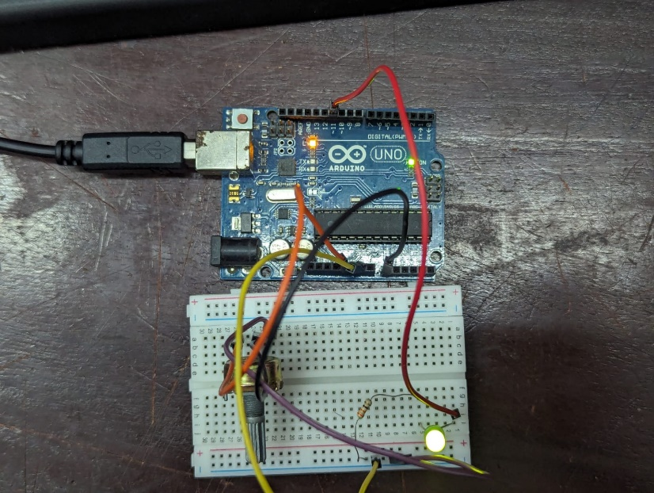

**Code :**

const int led1 = 11;

const int cap = 0;

void setup()

{

pinMode(led1,OUTPUT);

}

void loop()

{

int cap = analogRead(0);

cap = map(cap,0,1023,0,255);

analogWrite(led1,cap);

}